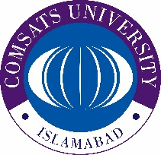

COMSATS University Islamabad

**Wah Campus**

**\*\*\*\***

**Hiring of Daily Wages**

Subject: **Advertisement for Hiring of Contingent Employee for cleanliness**

Applications are invited for Contingent Employee for cleanliness of the Campus. The salary of daily wages staff will be paid as per rate by the Government of Pakistan.

The interested candidates can send their applications along with copy of CNIC and Academics Documents if any to the undersigned by **20.10.2021**. Only short-listed candidates will be called for interview.

**(Additional Registrar)**

COMSATS University Islamabad,

Wah Campus, G. T. Road, Wah Cantt

(051) 9272614-15 (051) 4534200-2

[hr@ciitwah.edu.pk](mailto:hr@ciitwah.edu.pk)